|  |
| --- |
| Experiment No. 12 |
| Demonstrate the concept of Multi-threading |
| Date of Performance: 10/04/2024 |
| Date of Submission: 17/04/2024 |

**Experiment No. 12**

**Title:** Demonstrate the concept of Multi-threading

**Aim:** To study and implement the concept of Multi-threading

**Objective:** To introduce the concept of Multi-threading in python

**Theory:**

**Thread**

In computing, a **process** is an instance of a computer program that is being executed. Any process has 3 basic components:

* An executable program.
* The associated data needed by the program (variables, work space, buffers, etc.)
* The execution context of the program (State of process)

A **thread** is an entity within a process that can be scheduled for execution. Also, it is the smallest unit of processing that can be performed in an OS (Operating System).

In simple words, a **thread** is a sequence of such instructions within a program that can be executed independently of other code. For simplicity, you can assume that a thread is simply a subset of a process!

A thread contains all this information in a **Thread Control Block (TCB)**:

* **Thread Identifier:** Unique id (TID) is assigned to every new thread
* **Stack pointer:** Points to thread’s stack in the process. Stack contains the local variables under thread’s scope.
* **Program counter:** a register which stores the address of the instruction currently being executed by thread.
* **Thread state:** can be running, ready, waiting, start or done.
* **Thread’s register set:** registers assigned to thread for computations.
* **Parent process Pointer:** A pointer to the Process control block (PCB) of the process that the thread lives on.

**Program:**

#python prog for threading

#importing threading module

import threading

def print_cube(num) :

print("Cube : {}".format(num*num*num))

def print_square(num) :

print("Square : {}".format(num*num))

if __name__ == "__main__":

#creating the thread

t1 = threading.Thread(target= print_square, args=(12,))

t2 = threading.Thread(target= print_cube, args= (13,))

#starting the threads

t1.start()

t2.start()

#waiting until thread t1 is completely executed

t1.join()

#waiting until thread t2 is completely executed

t2.join()

#both threads executed

print("Done!")

**Ouput:**

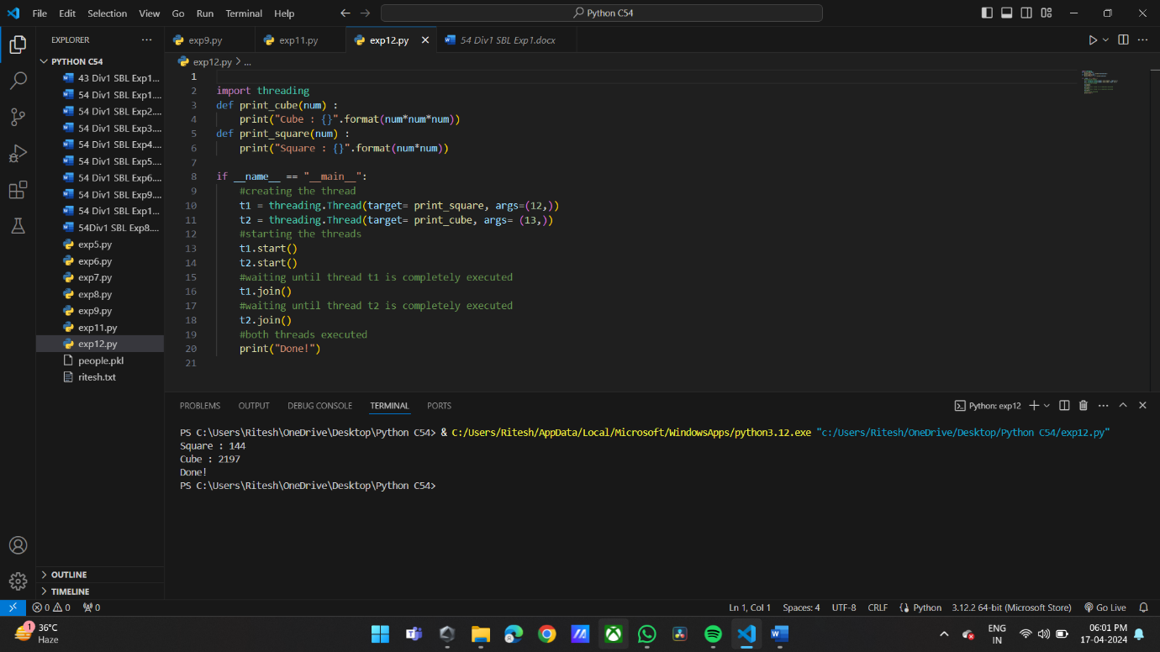

**Conclusion:**

Experiment demonstrated the concept of multithreading in Python, showcasing the ability to execute multiple tasks concurrently within a single process. By utilizing the threading module, the program executed separate functions concurrently, enhancing efficiency in computation. This experiment highlighted the benefits of multithreading in improving program performance by leveraging parallelism. Overall, the successful implementation of multithreading underscores its significance in optimizing resource utilization and enhancing program responsiveness.